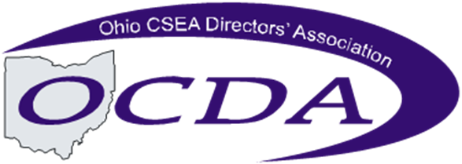

AGENDA
OCDA 2nd Quarter Attorney Networking
April 26, 2019 Cincinnati District @ Montgomery County
May 10, 2019 Canton/Cleveland District @ Summit County
May 16, 2019 Toledo District @ Hancock County
May 23, 2019 Columbus District @ Fairfield County

10:00am-12:00pm HB595 – Impact on Child Support Jurisdiction

The 132nd General Assembly passed HB595 on December 13, 2018, which was effective March 21, 2019. This Probate Omnibus bill also contained an amendment that made significant changes to jurisdiction that impacts child support cases. This training will cover an overview of the changes, a review of the impacted jurisdictional statutes, and a discussion of the practical impacts, including scenarios.

Lunch on your own

Afternoon Roundtable of issues for CSEA attorneys/hearing officers (optional)

